Project Proposal : Field Project 2024-25
PROJECT/case study NAME  ( Group Number ) | Inventory Management System  (Group Number 08)
ELECTRONICS AND TELECOMMUNICATION ENGINEERING

Vivekanand Education Society's Institute of Technology

Students Names  (Class /Roll Number) | Prince Eppakayal (D9A/13)
Students Names  (Class /Roll Number | Om Rajbhar (D9A/42)
Students Names  (Class /Roll Number | Vedant Jagdale (D9A/16)
Students Names  (Class /Roll Number | Jyotiraditya Bhosale (D9A/08)
Mentor Name | Dr.(Mrs.) Saylee Gharge
SEM/Year/CAY | IV/SE/2024-25
Problem Identification  (Scheme A )  based on observations during visits in  industry, Government/ Non-governmental organizations as well as the broader societal context. | Name of the company/organization:  KARAN ENTERPRISES  Address of the company/organization:  Ram Nagar Colony, Manik Nagar, Satara, Maharashtra 415004, India  Name of the incharge to whom you met :  Karan Karande  Designation: Owner
How is the problem identified ?  (Scheme A ) | Visiting the organization,  Interview with the Owner and talking with co-workers  (Attached Geotagged photos in the end )
Problem Statement  (Initial Goal) | The current system in rural spare part outlets relies on paper records for tracking purchases and sales, leading to frequent misplacement and forgery of documents, resulting in financial scams. The goal is to digitalize the process by designing and implementing a cost-effective QR code scanner to streamline inventory tracking and ensure data authenticity.
OBJECTIVE(s) | - Identification of components required for the QR code scanner.  - Designing and testing the QR code scanning and data transfer system using Python.  - Procuring components for hardware assembly and ensuring integration.  - Implementing the system using a Raspberry Pi, ensuring wired connectivity to minimize costs.  - Verifying scanner functionality and integrating it with a spreadsheet for real-time data logging.  - Demonstrating the solution in a real-world environment and addressing any faults
SPECIFIC: | The project focuses on developing a QR code scanner capable of extracting product information such as manufacturing date, purchase date, selling date, buyer's address, and authentication status.  - Team Members & Responsibilities:  - Vedant Jagdale: Component identification and hardware setup.  - Om Rajbhar: Python script development for data logging.  - Jyotiraditya Bhosale: Testing and debugging scanner hardware.  - Prince Eppakayal: Spreadsheet integration and documentation.  The project will conclude by April, allowing time for report preparation and demonstration.
MEASURABLE: | Deliver a functioning QR code scanner integrated with a Raspberry Pi, capable of real-time data transfer to a spreadsheet.  Optimize the scanner for quick and accurate scanning.  Ensure the system is portable, cost-effective, and usable in a rural setting.
ACHIEVABLE: | Use software tools such as Python for scripting and Google Sheets API for integration.  Hardware components include a QR code scanner module, Raspberry Pi, and power supply.  The team will learn and adapt Python programming and Raspberry Pi configuration to complete the project.
RELEVANT: | The project addresses a critical problem faced in rural spare part outlets, providing a scalable solution for inventory management. This prototype will act as a foundation for future enhancements, such as wireless connectivity or advanced product authentication mechanisms.
TIME-BOUND: | Objective 1 : 09-January-2025  Objective 2 : 09-February-2025  Objective 3 : 09-March 2025  Objective 4,5 : 31-March 2025  Demonstration and prototype launching, Final Report : First week of April 2025
S.M.A.R.T. Goal
Introduction :
A QR-based inventory management system is a modern solution designed to streamline tracking and managing inventory. By utilizing QR codes, it ensures real-time updates and reduces manual errors. Each component or product is assigned a unique QR code, enabling quick identification, retrieval, and data management. This system is user-friendly, scalable, and ideal for businesses seeking efficient inventory operations.
Description :
The proposed QR-based inventory management system aims to automate inventory tracking by integrating QR code technology. Each inventory item is tagged with a unique QR code containing details like product name, ID, quantity, and status. Users can scan these QR codes using a smartphone or QR scanner, which fetches or updates the data in a central database. The system includes features such as real-time inventory updates, defective/unused component tracking, and automated data reporting. It ensures seamless inventory operations by reducing manual effort and increasing accuracy. This solution is ideal for businesses managing large inventories, offering scalability and integration with cloud databases for remote access.
Block Diagrams :-
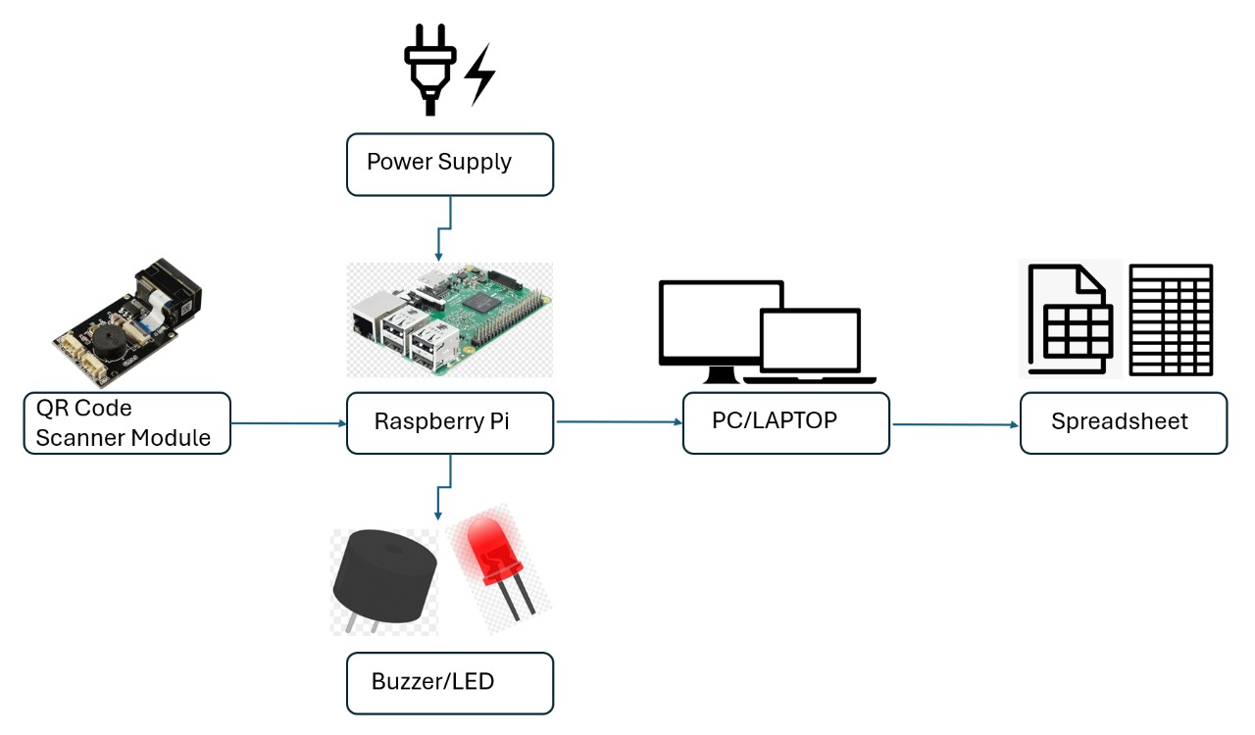

Mentor Name & Signature with date


